John’s Graduation Party


When: Saturday June 24, 2000
2 o’clock till ??
dinner @ 4 o’clock
Where: 130 S. Evergreen
Plymouth, MI
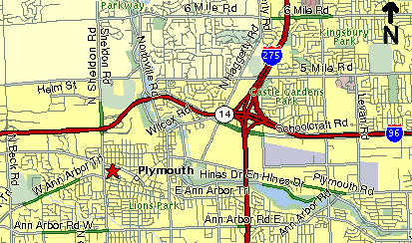
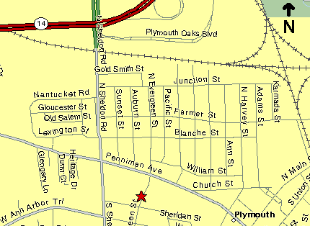
R.S.V.P. by June 16th
regrets only
734-455-9386


John’s Graduation Party

When: Saturday June 24, 2000
2 o’clock till ??
dinner @ 4 o’clock
Where: 130 S. Evergreen
Plymouth, MI
R.S.V.P. by June 16th
regrets only
734-455-9386

